The metaverse is coming:

What does it mean?

Advanced Mobile Development

Kristofer Gilluley B00391394

Contents

What is The Metaverse? 2

Who Owns the Metaverse? 2

Forms of The Metaverse Already in Existence 2

Second Life 2

Roblox 3

Access to The Metaverse 3

A Virtual Economy 3

Ownership of Virtual Items 3

Physical Item vs Virtual Item 4

Cryptocurrency and the Environment 4

Metas Metaverse and Facebook Controversy 4

What Does it Mean? 4

References 6

# What is The Metaverse?

The term was originally created in the science fiction novel Snow Crash written by Neal Stephenson. The concept become more popular in August 2021 when Meta, the company formally known as Facebook, announced large investments into building the Metaverse.

The metaverse is a concept of a large virtual environment in which users who are represented by avatars (a virtual representation of the user) are able to interact with each other regardless of physical location. The users are able to perform complex tasks. Some of these tasks are similar to the real world, such as having a discussion in a board room meeting, and other will use the virtual environment to give users experiences that are impossible in the real world. They can also participate in a variety of different activities and events, such as musical concerts. (Rasmussen, 2021)

The Metaverse is a complex environment that is an amalgamation of seven layers (Radoff, 2021):

1. 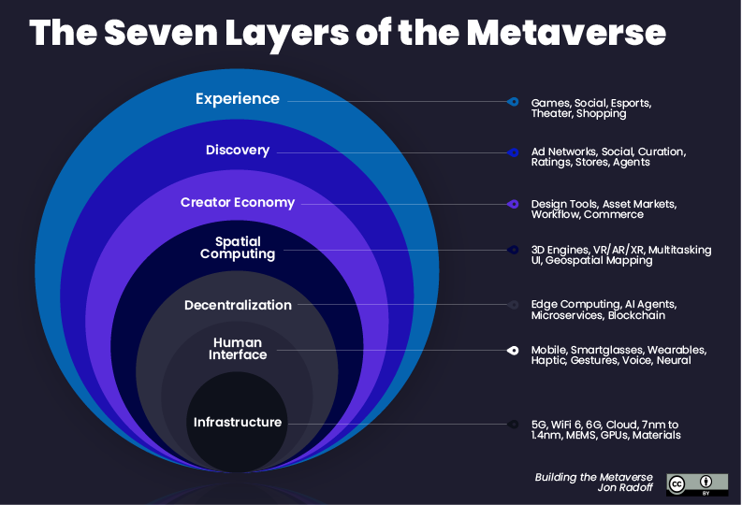Experience
2. Discovery
3. Creator Economy
4. Spatial Computing
5. Decentralisation
6. Human Interfaces
7. Infrastructure

# Who Owns the Metaverse?

Meta (despite their name change) cannot own the metaverse. They may have a platform titled Metaverse, but it will not stop other companies from creating and dispelling their own version. When Meta announced a large investment in the Metaverse several other companies, including Google and Microsoft, went public with their own intentions and investments (Patterson, 2021)

The Metaverse is a concept that cannot be owned by any one company, there are currently over 160 different companies all contributing to the creation and expansion of the Metaverse (XR Today Team, 2021).

# Forms of The Metaverse Already in Existence

There are already online communities which adhere to the idea of the Metaverse. This report will look at two of these communities in more detail: Second Life and Roblox.

## Second Life

Second Life is an online multimedia platform that was released in 2003. The creators of Second Life, Linden Lab, have dispelled the myth their creation is a game (Kalning, 2007). It is a 3D world in which users are able to interact, listen to music, socialise, and buy property. Even though Second Life predates Metas announcement by 18 years, there are many similarities between what the two entities wish to achieve. Many believe Second Life is the first iteration of an actualised Metaverse (Willie, 2022).

## Roblox

Roblox, released in 2006, is a virtual universe that lets users create and share experiences. It is a global platform designed to bring people together (Roblox, 2022). Roblox is primarily aimed at a younger audience (7–13-year-olds) but still hosts around nearly 55 million daily users (Stanton, 2022).

Second Life and Roblox are only two examples of platforms that can be described as part of the Metaverse. There are many other platforms, in which the users log on not to play a game, but to engage in social interactions.

# Access to The Metaverse

While the previous incarnations of the metaverse were accessible through computers or mobile devices, the new iterations intention is to use virtual reality headsets. The headset will help to immerse the users in the 3d virtual reality environment. It will add depth and amplify the user’s experience.

To access Meta’s Metaverse it is recommended that the user purchase their VR headset, the Oculus Quest 2, currently on the market for £299.99 (Argos, 2022). While the demand for VR headsets is increasing (IDC, 2021), a large portion of younger consumers do not have the funds to be able to purchase the headsets (Yee, 2019).

While there has been no confirmation that VR headsets are essential for access, all promotional materials display VR headsets prominently.

# A Virtual Economy

A large part of the experience of the Metaverse is that users will be able to buy, sell and trade items or products that will help the users avatar become a fully realised virtual version of themselves. With many users spending large amounts of cash, an in-platform economy will be established.

Each different platform that exists within the Metaverse will have its own individual virtual economy. Within each platform there will exist a currency that the user will be able to purchase, Second Life uses an in-platform currency named Linden Dollars (after the company that created the platform) and Roblox uses Robux. Many of these platforms will use cryptocurrency as the blueprint for the in-platform currency. The Sandbox and Decentraland platforms both use the Ethereum blockchain as the basis for currency (Speights, 22022).

The in-platform currency allows the user to purchase a variety of different items depending on the platform including virtual clothing, art, and land. Land within two of the most popular platforms are experiencing a purchasing-bubble in which users are buying land at incredible speeds (in anticipation that’ll it will be worth more money in the future), a plot of land within the Sandbox platform sold for the equivalent of $14,000 (Quiroz-Gutierrez, 2022).

## Ownership of Virtual Items

Users will be able to create, distribute, and receive virtual items. Users are able to claim ownership of these virtual items through the use of NFTs. A Non-Fungible Token(NFT) is a unit of data that is stored on the blockchain that is unable to be modified. When a user purchased a virtual item, it’ll be their name that is stored within the non-interchangeable data unit. If the user sells an NFT then the new user will become the owner of the virtual item. Every NFT has a history of transaction stored on the blockchain, which will include a list of previous owners and the user that owns the NFT currently (OpenSea, 2022).

## Physical Item vs Virtual Item

Users who are part of a community within a Metaverse spend money on items, despite there being no physical product. Roblox generated over 50% of its revenue through selling Robux (Roblox in-game currency) (Murray, 2021). The majority of this money will be spent to enhance gameplay, or for new items for the players avatar (Dean, 2022)

The volume of money spent in the online environment on virtual objects suggests that users don’t have the need to own a physical object after a purchase. This would also suggest that users within the Metaverse will have no objections to purchasing virtual objects if they can see value in ownership.

# Cryptocurrency and the Environment

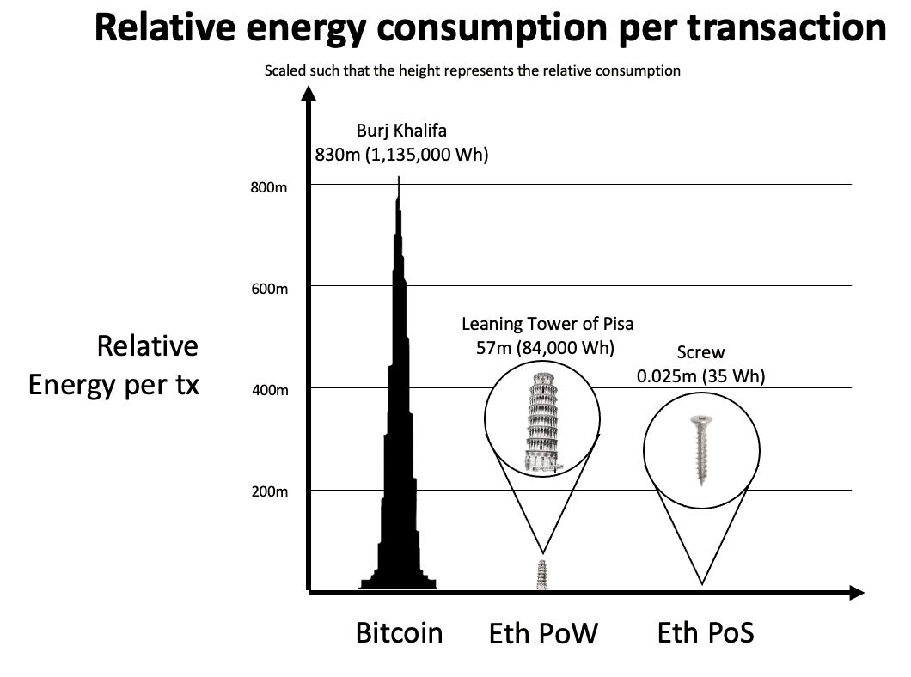Many cryptocurrencies are generated through computational mining, using large powerful computers that are using up lots of electricity. The environmental impact of cryptocurrencies is becoming of significant concern to environmental agencies (Bogna, 2022). It is estimated that Bitcoin mining uses more power each year than some countries (University of Cambridge , 2022)

The push for the Metaverse will only increase the need for cryptocurrency generation and will have a negative effect on greenhouse gas emissions. For cryptocurrency to become an ethically viable cryptocurrency, it must change functionality to it’s blockchain. It currently operates a Proof-of-Work (PoW) blockchain and will have to evolve into a Proof-of-Stake (PoS) chain as the environmental effect is significantly lower (Ethereum, 2022).

# Metas Metaverse and Facebook Controversy

After the Cambridge Analytica scandal, in which millions of user’s profiles were access and the personal data sold out to political campaigns (Alexandra Ma, 2019), trust in the Facebook company began to decline (Butow, 2018). Many American adults are concerned with Meta (formally Facebook) having control over all their personal information in Metas Metaverse (TechynoWorld, 2022).

For Metas Metaverse to flourish, the general public must begin to trust the social media company once again.

# What Does it Mean?

Many people believe that the Metaverse is to become the next iteration of the internet. A tool in which daily life won’t be able to function in its absence. A fully realised Metaverse is still many years away. In that time, if Ethereum is able to reduce its carbon footprint and the physical accessories required for entry are greatly reduced in price, then the Metaverse might become as part of daily life as social media has become. Users may begin to spend more money online to acquire virtual products. Which would result in less money being spent locally. Entire careers may begin and end in a virtual haze of the Metaverse.

Currently, the Metaverse is so young it’s not even in its infancy. It’s too early to be able to know if the Metaverse is going to revolutionise the way humans evolve and interact, or if it will amount to nothing. Many large tech companies are investing gigantic sums of money in the hopes of being the first to crack the Metaverse. When there is enough capital behind something, it can be difficult for it to fail.

Metas Metaverse is a virtual utopian dream in which everyone is able to live the life they have always wanted. Everyone can get in, if they can pay the price.

# References

Alexandra Ma, B. G., 2019. *Facebook understood how dangerous the Trump-linked data firm Cambridge Analytica could be much earlier than it previously said. Here's everything that's happened up until now..* [Online]   
Available at: https://www.businessinsider.com/cambridge-analytica-a-guide-to-the-trump-linked-data-firm-that-harvested-50-million-facebook-profiles-2018-3?r=US&IR=T  
[Accessed 30 03 2022].

Argos, 2022. *Oculus Quest.* United Kingdom: argos.co.uk/product/9461987?istCompanyId=a74d8886-5df9-4baa-b776-166b3bf9111c&istFeedId=30f62ea9-9626-4cac-97c8-9ff3921f8558&istItemId=piwipirqx&istBid=t&&cmpid=GS001&_$ja=tsid:59157%7cacid:534-693-8244%7ccid:9562883184%7cagid:101271432634%7ctid:pla-14748.

Bogna, J., 2022. *What Is the Environmental Impact of Cryptocurrency?.* [Online]   
Available at: https://uk.pcmag.com/old-cryptocurrency/138047/what-is-the-environmental-impact-of-cryptocurrency  
[Accessed 29 3 2022].

Butow, D., 2018. *Trust in Facebook has dropped by 66 percent since the Cambridge Analytica scandal.* [Online]   
Available at: https://www.nbcnews.com/business/consumer/trust-facebook-has-dropped-51-percent-cambridge-analytica-scandal-n867011  
[Accessed 30 3 2022].

Dean, B., 2022. *Roblox User and Growth Stats 2022.* [Online]   
Available at: https://backlinko.com/roblox-users  
[Accessed 29 3 2022].

Ethereum, 2022. *Ethereum energy consumption.* [Online]   
Available at: https://ethereum.org/en/energy-consumption/  
[Accessed 29 3 2022].

IDC, 2021. *AR/VR Headset Forecast, 2021Q3.* [Online]   
Available at: https://www.idc.com/promo/arvr  
[Accessed 28 3 2022].

Kalning, K., 2007. *If Second Life isn't a game, what is it?.* [Online]   
Available at: https://www.nbcnews.com/id/wbna17538999#.U9uyeEi49yw  
[Accessed 28 3 2022].

Murray, P., 2021. *How Does Roblox Make Money?.* [Online]   
Available at: https://mywallst.com/blog/how-does-roblox-make-money/  
[Accessed 29 3 2022].

OpenSea, 2022. *Where Can I Check the History of an NFT.* [Online]   
Available at: https://support.opensea.io/hc/en-us/articles/1500003082601-Where-can-I-check-the-history-of-an-NFT-  
[Accessed 29 3 2022].

Patterson, D., 2021. *The Metaverse is already here: 5 companies building our virtual reality future.* [Online]   
Available at: https://www.cbsnews.com/news/metaverse-is-already-here-5-companies-building-our-virtual-reality-future/  
[Accessed 28 3 2022].

Quiroz-Gutierrez, M., 2022. *The cheapest real estate on popular metaverse platforms is already selling for more than $13,000.* [Online]   
Available at: https://fortune.com/2022/01/05/cheapest-digital-land-metaverse-selling-more-than-13000/  
[Accessed 29 3 2022].

Radoff, J., 2021. *The Metaverse value-Chain.* [Online]   
Available at: https://medium.com/building-the-metaverse/the-metaverse-value-chain-afcf9e09e3a7  
[Accessed 28 03 2022].

Rasmussen, M., 2021. *Touring The Musical Metaverse: Virtual Concerts are Here to Stay.* [Online]   
Available at: https://www.virtualhumans.org/article/touring-the-musical-metaverse-virtual-concerts-are-here-to-stay  
[Accessed 28 3 2022].

Roblox, 2022. *What is Roblox.* [Online]   
Available at: https://corp.roblox.com/parents/  
[Accessed 28 3 2022].

Speights, K., 22022. *Could Ethereum Be the Biggest Metaverse Cryptocurrency Winner?.* [Online]   
Available at: https://www.fool.com/investing/2022/02/28/could-ethereum-be-the-biggest-metaverse-cryptocurr/  
[Accessed 29 3 2022].

Stanton, R., 2022. *If Roblox's daily users were a country, it would be bigger than Canada.* [Online]   
Available at: https://www.pcgamer.com/uk/if-robloxs-daily-users-were-a-country-it-would-be-bigger-than-canada/  
[Accessed 28 3 2022].

TechynoWorld, 2022. *Majority of US consumers say no to Meta owning metaverse data – Survey.* [Online]   
Available at: https://techyno.com/majority-of-us-consumers-say-no-to-meta-owning-metaverse-data-survey/  
[Accessed 30 3 2022].

University of Cambridge , 2022. *Cambridge Bitcoin Electricity Consuption Index.* [Online]   
Available at: https://ccaf.io/cbeci/index/comparisons  
[Accessed 29 3 2022].

Willie, M., 2022. *Second Life creator is coming back to fix the metaverse.* [Online]   
Available at: https://www.inputmag.com/culture/second-life-creator-is-coming-back-to-fix-the-metaverse  
[Accessed 28 3 2022].

XR Today Team, 2021. *Who is Building the Metaverse? A Group of 160+ Companies, and You.* [Online]   
Available at: https://www.xrtoday.com/virtual-reality/who-is-building-the-metaverse-a-group-of-160-companies-and-you/  
[Accessed 28 3 2022].

Yee, N., 2019. *Older Gamers Who Can Afford VR Tend to Care Less About the Gaming Motivations Linked to VR Adoption.* [Online]   
Available at: https://quanticfoundry.com/2019/03/01/vr-adoption/  
[Accessed 28 3 20222].